Department of Computer Science and Engineering (Data Science)
CSDS-A | Batch A17 (CSE - Data Science, Section A)
CropSight: Smart Crop Delivery with AI-Based Price and Quality Intelligence
(CropSight)
S.No. | Student name | Roll / hall ticket no.
1 | G.PRANAVI | 23K91A6765
2 | G.SIRI CHANDANA | 23K91A6763
3 | A.NIKHIL | 23K91A6715
4 | G.VISHNU VARDHAN | 23K91A6754
Under the guidance of: K. Mounika, [DESIGNATION]
DESIGN AND IMPLEMENTATION
This document describes the design of CropSight and how it was implemented: the architecture, the modules, the database schema, the API, key code walkthroughs, and the reasoning behind the main implementation decisions.

1 System Architecture
CropSight is a single-machine web application: a React front end, a FastAPI back end, a SQLite database, two trained scikit-learn models and a sensor simulator. No external service is called. The figure below shows the layers.
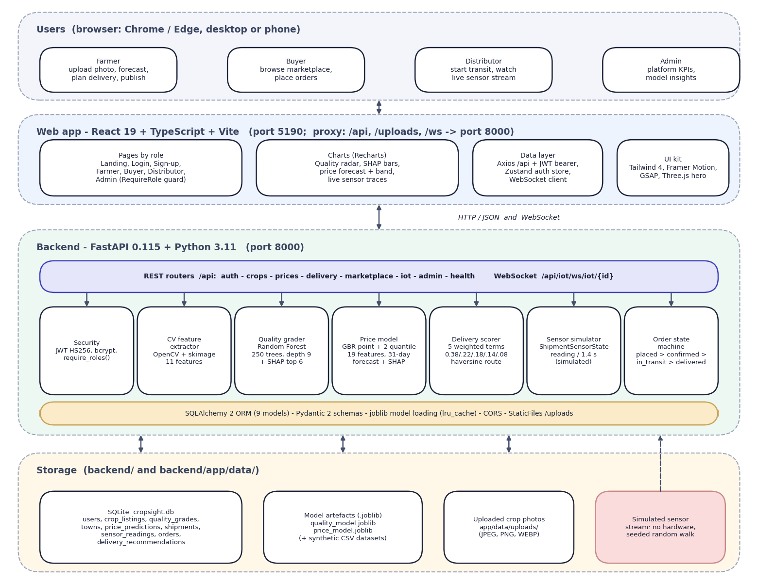
Fig. 1: System architecture of CropSight
The diagram shows five layers. At the top are the four kinds of user, each working in a browser: the farmer uploads a photo, forecasts the price, plans delivery and publishes; the buyer browses the marketplace and places orders; the distributor starts transit and watches the live sensor stream; the admin sees platform figures and model insights. Below them is the React 19 web application served by Vite on port 5190, which proxies /api, /uploads and /ws to the backend. It has role-based pages, Recharts charts (quality radar, SHAP bars, price forecast with its band, live sensor traces), a data layer (Axios with the bearer token, a Zustand authentication store and the WebSocket client) and the user-interface kit.
The backend is a FastAPI application on port 8000. Its REST routers (auth, crops, prices, delivery, marketplace, iot, admin and health) and one WebSocket route call seven building blocks: security (JWT and bcrypt, require_roles), the image feature extractor, the quality grader (Random Forest with SHAP), the price model (gradient boosting with two quantile models, a 31-day forecast and SHAP), the delivery scorer, the sensor simulator and the order state machine. SQLAlchemy maps nine models to SQLite; the joblib model files are loaded once and cached. Storage is local: the cropsight.db file, the two model artefacts with their synthetic CSV datasets, and the uploaded photos. The shaded box marks the sensor source as simulated: no hardware is connected.
The design follows five principles. Explain every prediction: the grade and the forecast each return the SHAP contributions that produced them, so the farmer sees the drivers and not only the result. Keep scoring transparent: the buyer ranking is a stated weighted sum, not a second black-box model. Enforce roles on the server: the web app hides screens a role should not see, but the decision is made by require_roles in the API and by the order state machine. Keep the heavy work local: image analysis, the models and the SHAP explanations run on the CPU in the same process. Isolate what is simulated: the market context for the price forecast (market_context()) and the sensor stream (ShipmentSensorState) are the only two places where data is generated instead of read, so a real weather and price feed or real sensors could replace them without changing the routes.

2 Module Design
Table 1: Modules of CropSight
Module | Code | Responsibility
Application | backend/app/main.py | Creates the FastAPI app, CORS, the /uploads static mount, the start-up table creation and the /api/health route; includes the seven routers
Configuration and database | app/core/config.py, database.py | Settings (secret, algorithm, token lifetime, database URL), engine, session dependency
Security | app/core/security.py | bcrypt hashing, HS256 JWT creation and decoding, get_current_user, require_roles
Auth API | app/api/auth.py | Sign-up for farmer, buyer or distributor, login, current user
Crops API | app/api/crops.py | Upload with validation, grading, own listings, listing detail, publish
Prices API | app/api/prices.py | Catalogue options and price prediction (uses the listing's grade when a listing is given)
Delivery API | app/api/delivery.py | Owner-only recommendation, stored as a row
Marketplace API | app/api/marketplace.py | Listings with filters, orders, role-scoped order list, status transitions that create shipments
IoT API | app/api/iot.py | Shipments in transit, last 60 readings, WebSocket stream that stores each reading
Admin API | app/api/admin.py | Platform counts and gross volume; model cards with importances and training-data disclosure
Quality pipeline | app/ml/quality/ | feature_extraction.py (11 features), generate_dataset.py (synthetic profiles), train_model.py (Random Forest), infer.py (grade, probabilities, SHAP)
Price pipeline | app/ml/price/ | features.py (catalogue, 19 features, market context, price formula), generate_dataset.py, train_model.py (point and two quantile models), infer.py (forecast, best day, SHAP)
Delivery engine | app/ml/delivery/recommend.py | Weighted score, haversine distance, transit time, spoilage risk, top five buyers and best route
Sensor simulator | app/ml/iot/simulate.py | Seeded random walk with injected anomalies and the alert rule
Models and schemas | app/models/, app/schemas/ | Nine SQLAlchemy models and the Pydantic request and response types
Seed script and tests | scripts/seed_db.py, tests/ | Demo accounts, towns and one sample listing; 39 pytest tests
Web application | frontend/src/ | 17 page and layout components in six groups (marketing, auth, farmer, buyer, distributor, admin), 23 shared components, the API client, the authentication store and the types

The package app/ml/explain/ exists but is empty: SHAP is called directly inside the two inference modules.

3 Database Design
The database is SQLite, created by SQLAlchemy 2 at start-up with create_all; there are no migrations. Results that are read and written whole (class probabilities, features, SHAP explanations, forecasts, ranked buyers) are stored as JSON columns. Uploaded photographs are stored as files under app/data/uploads with random names, and the table keeps only the path.
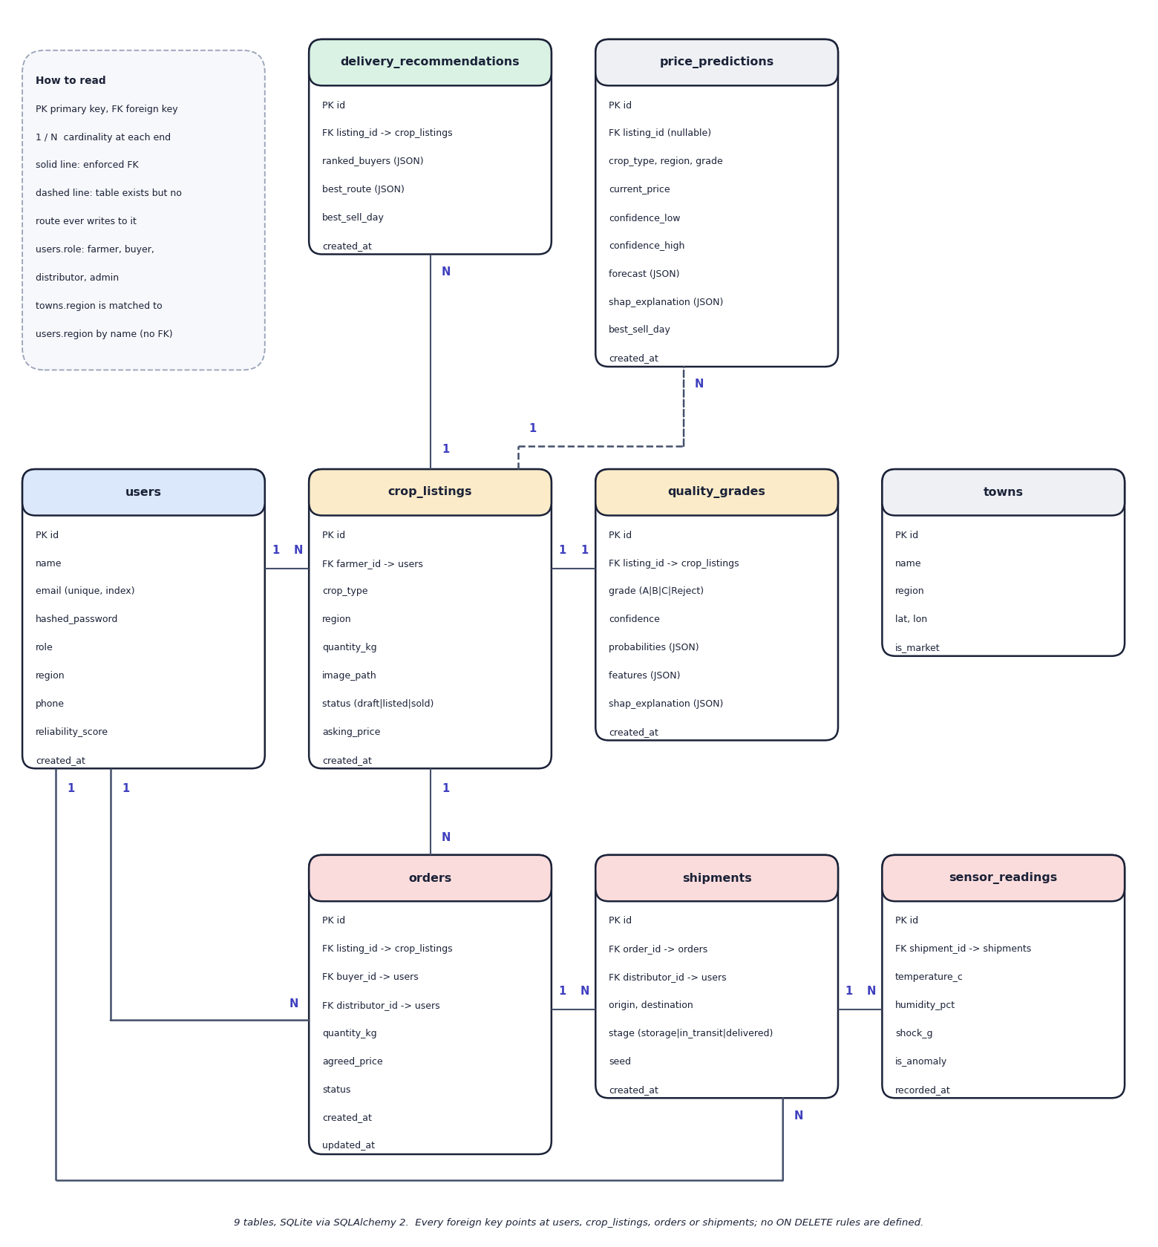
Fig. 2: Entity-relationship diagram (9 tables)
Nine tables are created by SQLAlchemy in SQLite. A user (farmer) owns many crop listings; each listing has at most one quality grade, many delivery recommendations and, once sold, orders. An order refers to a listing and to a buyer, and optionally to the distributor who took it; a shipment refers to an order and a distributor, and a shipment has many sensor readings. The towns table holds the eight market towns with coordinates and is joined to users and listings by region name only, not by a foreign key. The price_predictions table is drawn dashed: the model and table exist, but no route writes to it. No foreign key has an ON DELETE rule.
Table 2: Database tables
Table | Purpose | Key columns
users | Accounts of all four roles | id, name, email (unique, indexed), hashed_password (bcrypt), role (farmer, buyer, distributor, admin), region, phone, reliability_score (default 4.5), created_at
crop_listings | A graded crop lot | id, farmer_id (FK users), crop_type, region, quantity_kg, image_path, status (draft, listed, sold), asking_price, created_at
quality_grades | Grade of a listing | id, listing_id (FK), grade (A, B, C, Reject), confidence, probabilities (JSON), features (JSON, 11 values), shap_explanation (JSON), created_at
towns | Eight market towns | id, name, region, lat, lon, is_market
price_predictions | Defined for stored forecasts; never written by any route | id, listing_id (FK, nullable), crop_type, region, grade, current_price, confidence_low/high, forecast (JSON), shap_explanation (JSON), best_sell_day, created_at
delivery_recommendations | Stored delivery plan | id, listing_id (FK), ranked_buyers (JSON), best_route (JSON), best_sell_day, created_at
orders | A buyer's order | id, listing_id (FK), buyer_id (FK users), distributor_id (FK users, nullable), quantity_kg, agreed_price, status (placed, confirmed, in_transit, delivered, cancelled), created_at, updated_at
shipments | A transit of one order | id, order_id (FK, nullable), distributor_id (FK, nullable), origin, destination, stage (storage, in_transit, delivered), seed, created_at
sensor_readings | One simulated reading | id, shipment_id (FK), temperature_c, humidity_pct, shock_g, is_anomaly, recorded_at

Two design points should be noted. First, the schema keeps the quality grade in its own table with a one-to-one relationship to the listing, so a listing can exist as a draft before it is graded; if grading fails after the draft is saved, the draft remains without a grade, which is one of the known gaps. Second, no foreign key declares an ON DELETE rule and passwords are never stored in clear text: hashed_password holds a bcrypt hash.

4 Application Architecture
Fig. 3: System architecture of CropSight
The backend is a FastAPI application organised in layers. Routers in api/ (auth, crops, prices, delivery, iot, marketplace, admin) validate input and enforce roles; the machine-learning services live in ml/quality, ml/price, ml/delivery and ml/iot; SQLAlchemy models in models/ map to nine tables; Pydantic schemas in schemas/ define request and response types; core/ holds configuration, the database session and the JWT and password helpers. The models are loaded lazily on first use and cached; if an artefact is missing it is trained on demand. Uploaded images are written to app/data/uploads and served at /uploads.
The frontend is a single-page React 19 application in TypeScript built with Vite. React Router defines the routes for four roles (farmer, buyer, distributor, admin), each wrapped in a RequireRole guard that redirects a user to their own home; Zustand keeps the token and user in browser storage; an Axios instance attaches the bearer token and signs the user out on a 401 response; Recharts draws the radar, SHAP, forecast and sensor charts; Tailwind CSS 4, Framer Motion, GSAP, Lenis and a Three.js hero scene give the presentation. The Vite development server proxies /api, /uploads and /ws to the backend, so the browser sees a single origin.
Table 3: Technology stack of the implementation
Layer | Technology | Version
Language and runtime | Python; Node.js | 3.11.9; 24.19.0
Web framework | FastAPI with uvicorn; Pydantic | 0.115.6; 0.32.1; 2.10.3
Database | SQLAlchemy over SQLite | 2.0.36
Machine learning | scikit-learn; SHAP; NumPy; pandas | 1.5.2; 0.46.0; 1.26.4; 2.2.3
Computer vision | OpenCV (headless); scikit-image; Pillow | 4.10; 0.24; 11.0
Security | python-jose (HS256 JWT); passlib with bcrypt | 3.3.0; 1.7.4 with bcrypt 4.0.1
Frontend | React; Vite; Tailwind CSS; TypeScript | 19.x; 8.x; 4.x; 6.0
Size | Backend Python; frontend TypeScript | 1,980 lines; 3,302 lines (17 page and 23 other components)

The order of the pages follows the roles. Farmer: dashboard (upload and listings), listing workspace (grade, forecast, delivery plan, publish), orders. Buyer: marketplace with crop, region and grade filters, listing detail, orders. Distributor: active deliveries and live monitoring. Admin: overview and model insights. Public pages are the landing page, log-in and sign-up.

5 API Design
The API is REST over JSON under /api with one WebSocket, 21 endpoints in all. Interactive documentation (Swagger UI) is served by FastAPI at /docs. Every endpoint except health, sign-up, log-in and the option list needs Authorization: Bearer <token>; the WebSocket is not authenticated (see section 6.10). Errors have the form {"detail": "message"} with status 400, 401, 403, 404 or 422.
Table 4: API endpoints
Method | Path | Role | Purpose
GET | /api/health | any | Liveness
POST | /api/auth/signup | public | Create a farmer, buyer or distributor; returns a JWT
POST | /api/auth/login | public | Returns a JWT and the user
GET | /api/auth/me | signed in | Current user
POST | /api/crops/upload | farmer | Multipart photo and crop, region, quantity: draft listing, features, grade, SHAP
GET | /api/crops/mine | farmer | Own listings
GET | /api/crops/{id} | signed in | One listing
POST | /api/crops/{id}/list | owner farmer | Publish with an asking price
GET | /api/prices/options | public | Crops, regions, grades
POST | /api/prices/predict | signed in | Price, band, 31-day forecast, best day, SHAP
GET | /api/delivery/{id}/recommend | owner farmer | Top-5 buyers, route, best day; stored
GET | /api/marketplace/listings | signed in | Listed crops, filters crop, region, grade
GET | /api/marketplace/listings/{id} | signed in | Listing detail
POST | /api/marketplace/orders | buyer | Place an order; listing becomes sold
GET | /api/marketplace/orders/mine | signed in | Role-scoped orders
PATCH | /api/marketplace/orders/{id}/status | farmer, distributor, admin | Move an order along the state machine
GET | /api/iot/shipments | signed in | Shipments in transit
GET | /api/iot/shipments/{id}/history | signed in | Latest 60 sensor rows
WS | /api/iot/ws/iot/{id} | none | Sensor reading every 1.4 s, stored
GET | /api/admin/overview | admin | Users, listings, orders, volume
GET | /api/admin/model-insights | admin | Model cards and importances

Example: grade a crop. POST /api/crops/upload takes multipart/form-data with crop_type, region, quantity_kg and image, and returns the listing with its quality_grade object (grade, confidence, probabilities, features, shap_explanation.top_features). Example: price. The request and an abbreviated response:
Listing: Price request and response (shape)
POST /api/prices/predict
{"crop_type": "Tomato", "region": "Sunridge Valley", "grade": "B", "listing_id": 7}
-> {"current_price": 2272.0, "confidence_low": 2068.0, "confidence_high": 2272.0,
"forecast": {"0": ..., "1": ..., ... "30": ...}, "best_sell_day": 14, "shap_explanation": {"top_features": [...]}}

When listing_id refers to a graded listing, the grade of that listing replaces the grade in the request, so the farmer cannot price a lot at a better grade than it received.
The order status endpoint accepts {"status": "confirmed"}, "cancelled", "in_transit" or "delivered"; an illegal move returns 400 and an unauthorised actor 403.

6 Key Code Walkthroughs

6.1 Foreground mask and texture features
The mask removes the bright, unsaturated table so that colour and texture statistics describe the crop; the co-occurrence matrix is built on the masked grey image.
Listing: Foreground mask in ml/quality/feature_extraction.py
_, mask = cv2.threshold(sat, 0, 255, cv2.THRESH_BINARY + cv2.THRESH_OTSU)
bright_bg = (val > 235) & (sat < 25)
mask[bright_bg] = 0
kernel = np.ones((5, 5), np.uint8)
mask = cv2.morphologyEx(mask, cv2.MORPH_OPEN, kernel)
mask = cv2.morphologyEx(mask, cv2.MORPH_CLOSE, kernel)
coverage = mask.mean() / 255.0
if coverage < 0.03 or coverage > 0.98:
mask = np.full(bgr.shape[:2], 255, dtype=np.uint8)

Listing: Grey-level co-occurrence features in ml/quality/feature_extraction.py
glcm = graycomatrix(
(gray_masked // 16).astype(np.uint8),
distances=[2],
angles=[0, np.pi / 4, np.pi / 2, 3 * np.pi / 4],
levels=16,
symmetric=True,
normed=True,
)
texture_contrast = float(np.clip(graycoprops(glcm, "contrast").mean() / 40.0, 0.0, 1.0))
texture_homogeneity = float(graycoprops(glcm, "homogeneity").mean())
texture_energy = float(graycoprops(glcm, "energy").mean())

6.2 Grading with an explanation
grade_image() extracts the features, takes the class probabilities of the forest and attaches the six largest SHAP contributions for the predicted class.
Listing: Grade and probabilities in ml/quality/infer.py
proba = model.predict_proba(vector)[0]
classes = list(model.classes_)
grade = classes[int(np.argmax(proba))]
confidence = float(np.max(proba))
probabilities = {cls: float(p) for cls, p in zip(classes, proba)}

explainer = _explainer()
shap_values = explainer.shap_values(vector)
class_idx = classes.index(grade)
if isinstance(shap_values, list):
contribs = shap_values[class_idx][0]
else:
contribs = shap_values[0, :, class_idx]

6.3 Price forecast and best sell day
The context is walked forward one day at a time with an exponential blend, the point model is evaluated for each day, and the best day is the maximum over the first fourteen.
Listing: Forecast loop in ml/price/infer.py
forecast: dict[int, float] = {}
running_ctx = market_context(crop, region, today)
for offset in range(0, FORECAST_DAYS + 1):
d = today + timedelta(days=offset)
target_ctx = market_context(crop, region, d)
running_ctx = {k: 0.8 * running_ctx[k] + 0.2 * target_ctx[k] for k in running_ctx}
dth = max(0, days_to_harvest - offset)
row = build_row_from_context(crop, region, grade, d, running_ctx, dth, year_trend=row0["year_trend"])
vec = row_to_vector(row)
forecast[offset] = float(point_model.predict(vec)[0])

window = {k: v for k, v in forecast.items() if k <= SPOILAGE_WINDOW_DAYS}
best_sell_day = max(window, key=window.get)

Listing: Best sell day in ml/price/infer.py
window = {k: v for k, v in forecast.items() if k <= SPOILAGE_WINDOW_DAYS}
best_sell_day = max(window, key=window.get)

6.4 Delivery score
Each buyer is scored on five normalised terms; the weights are constants that sum to one, so every ranking can be explained term by term.
Listing: Weighted match score in ml/delivery/recommend.py
price_norm = min(offered_price / (base_price * 1.2), 1.0)
distance_norm = max(0.0, 1.0 - min(distance_km, 500) / 500)
quality_fit = {"A": 1.0, "B": 0.85, "C": 0.6, "Reject": 0.1}.get(grade, 0.5)
reliability_norm = min(buyer.reliability_score / 5.0, 1.0)
transit_days = distance_km / 380 + 0.5
spoilage_risk = min(transit_days / spoilage_span, 1.0)

score = (
WEIGHTS["price"] * price_norm
+ WEIGHTS["distance"] * distance_norm
+ WEIGHTS["quality_fit"] * quality_fit
+ WEIGHTS["reliability"] * reliability_norm
+ WEIGHTS["spoilage_risk"] * (1 - spoilage_risk)
)

scored.append(
{

6.5 Order state machine
Transitions are declared in one table and checked before any role rule is applied; a distributor who starts transit also creates the shipment whose seed drives the simulator.
Listing: Allowed order transitions in api/marketplace.py
VALID_TRANSITIONS = {
"placed": {"confirmed", "cancelled"},
"confirmed": {"in_transit", "cancelled"},
"in_transit": {"delivered"},
}

6.6 Sensor simulator step
The simulator moves each quantity by a small random step, injects an event when the countdown reaches zero and decides whether the reading is an anomaly.
Listing: ShipmentSensorState.step() in ml/iot/simulate.py
def step(self) -> dict:
self.temperature_c += self._rng.uniform(-0.35, 0.35)
self.humidity_pct += self._rng.uniform(-1.2, 1.2)
self.shock_g = max(0.0, self._rng.gauss(0.3, 0.25))

self._anomaly_countdown -= 1
is_anomaly = False
if self._anomaly_countdown <= 0:
kind = self._rng.choice(["temp_spike", "humidity_spike", "shock"])
if kind == "temp_spike":
self.temperature_c += self._rng.uniform(4.0, 8.0)
elif kind == "humidity_spike":
self.humidity_pct += self._rng.uniform(12.0, 20.0)
else:
self.shock_g += self._rng.uniform(2.2, 4.0)
is_anomaly = True
self._anomaly_countdown = self._rng.randint(25, 55)

self.temperature_c = max(-5.0, min(35.0, self.temperature_c))
self.humidity_pct = max(20.0, min(98.0, self.humidity_pct))

6.7 Token creation and role guard
Listing: JWT creation in core/security.py
def create_access_token(subject: str, extra: dict | None = None) -> str:
expire = datetime.now(timezone.utc) + timedelta(minutes=settings.access_token_expire_minutes)
payload = {"sub": subject, "exp": expire}
if extra:
payload.update(extra)
return jwt.encode(payload, settings.secret_key, algorithm=settings.algorithm)

Listing: Role dependency in core/security.py
def require_roles(*roles: str):
def dependency(user: User = Depends(get_current_user)) -> User:
if roles and user.role not in roles:
raise HTTPException(status_code=status.HTTP_403_FORBIDDEN, detail="Not authorized for this action")
return user

return dependency

7 Implementation Decisions and Reasoning
The table lists the main implementation decisions and the reason for each. Several of them are consequences of two constraints: the project had no real labelled data, and it had to run on one ordinary computer without a graphics card.
Table 5: Implementation decisions
Decision | Why
Classical machine learning (Random Forest [10], Gradient Boosting [11]) instead of a deep network | No labelled image set existed, the machine has no GPU, and the 11 features are computed from real pixels, so the model stays small, trains in seconds and can be explained with SHAP. The batch abstract speaks of deep learning; the shipped grader is not one
Hand-crafted computer-vision features (HSV colour with an Otsu threshold [17], GLCM texture [15], Canny edges [16], blemish and size) | Each feature has a meaning the farmer can read in the radar and SHAP charts; extraction is deterministic and needs no training data
Train on generated feature vectors with 6% label noise | A real labelled set was not available; the noise stops the forest from memorising separable clusters. The cost, shown in Chapter 8, is that real photographs fall outside the profiles
SHAP TreeExplainer for both models | Exact, fast attributions for tree ensembles [13], [14]; the top six contributions are returned with every grade and price
Quantile Gradient Boosting for the price band | Two extra models (alpha 0.15 and 0.85) give a 70% band without distributional assumptions [11], [12]; the displayed band is clamped to contain the point estimate
Forecast by walking a market context forward 30 days | A feed of weather, demand and supply did not exist, so the context is generated deterministically from crop, region and date; the same inputs give the same forecast on a day
Transparent weighted score for delivery, not a trained model | No delivery history exists; weights 0.38 / 0.22 / 0.18 / 0.14 / 0.08 can be read and defended, and the ranking was shown to be stable
Simulated sensor stream over a WebSocket | No hardware; a seeded random walk with injected events exercises the real path (WebSocket, history table, alert banner)
FastAPI and SQLAlchemy with SQLite; scikit-learn [18], scikit-image [19] and OpenCV [20] for the models and features | Typed request and response models, automatic documentation, no database server to install; sufficient for a single-machine demonstration
JWT bearer tokens and a role dependency on every route | Stateless authentication [23]; bcrypt password hashes; each role can reach only its own routes, and admins cannot be created by sign-up
Order state machine in one dictionary | placed to confirmed to in-transit to delivered is checked in one place, and each transition is bound to the role that may perform it
Vite proxy for /api, /uploads and /ws | The browser talks to one origin, so no cross-origin configuration is needed during development; ports 8000 and 5190 are fixed
Run the API without the auto-reload option | Observed in this setup: reload left orphaned worker processes holding the port with stale code; restart manually after backend edits
Models retrained at start-up if the artefact is missing | A fresh checkout works after the seed script; artefacts, datasets, the database and uploads are not committed
Admin page that states the training data | The synthetic origin of both models is shown in the application itself, not hidden

8 Security and Error Handling
- Passwords are hashed with bcrypt through passlib; sign-up requires a password of at least six characters and a syntactically valid e-mail address (reserved domains such as .test are rejected by the validator).
- Tokens. A signed JWT [23] (HS256, python-jose) with a seven-day expiry carries the user id and role; every protected route decodes it and loads the user, and an invalid or tampered token returns 401.
- Role guards. require_roles() is a dependency that returns 403 for other roles; ownership of a listing is checked in the route (a foreign listing returns 404); the front end repeats the role check with RequireRole for navigation only.
- Registration. Only farmer, buyer and distributor can be created through the API; the admin account exists only in the seed script.
- Uploads. Only JPEG, PNG and WEBP content types are accepted, with a maximum of 8 MB; files are stored under a random UUID name.
- Order integrity. The state machine rejects skipped or repeated transitions, a listing can be ordered once, and delivery can only be recorded by the assigned distributor or the admin.
- CORS allows the origins in config.py (port 5173), which is not the port the app is served on (5190); the app works because the browser reaches the API through the Vite proxy on its own origin.
Known gaps, found by testing and review, and stated so that they are not mistaken for features. (1) A default signing secret is committed in config.py and must be replaced for any shared deployment. (2) The sensor WebSocket and the shipment history need no token, and any signed-in user can read any listing or shipment. (3) Any distributor can start transit on any confirmed order. (4) Order quantity and price are not validated: zero, negative or larger-than-listed values are accepted. (5) Crop and region names are not checked against the catalogue. (6) A corrupt image sent with an image content type makes the grader raise, the request fails with HTTP 500 and the draft listing created just before is left behind without a grade. (7) The admin 'gross volume' multiplies a price per quintal by kilograms and so overstates the figure by a factor of 100. (8) There is no rate limiting, HTTPS or audit log. Gaps 4, 5 and 6 are recorded as expected-failure tests (Chapter 7).

9 User Interface Design
The web application has one landing page, a log-in page and a sign-up page, and a sidebar layout for each role. The farmer has a dashboard (upload form and own listings), a listing workspace (grade, price forecast, delivery planner, publication) and an orders page. The buyer has the marketplace, a listing detail page with an order dialog, and an orders page. The distributor has an active-deliveries page and a live monitoring page. The admin has an overview and a model-insights page. A route guard sends a user who opens another role's address back to their own home page.
Design decisions follow from the users. Every grade is shown with a badge, the confidence and a six-axis quality radar next to the SHAP bars that explain it. The forecast chart shows the confidence band and marks the best day to sell. The live monitoring page draws three sensor traces, shows a banner while the latest reading is out of range, and raises a toast when an alert begins. The admin model-insights page prints the algorithm, the measured accuracy, the feature importances and a sentence stating that the training data were synthetic. Colour is paired with text labels and the layout adapts to narrow screens.
One limitation of the interface should be stated: the statistics on the landing page (crops graded, price uplift, grading accuracy, farmers onboarded) and its price ticker are fixed marketing text in the page source, not measurements, and the figures in this report are the measured ones. The sign-in page also offers one-click demo accounts for the four roles. The screens below were captured from the running application with real crop photographs; the complete set is in Chapter 8 and Appendix C.
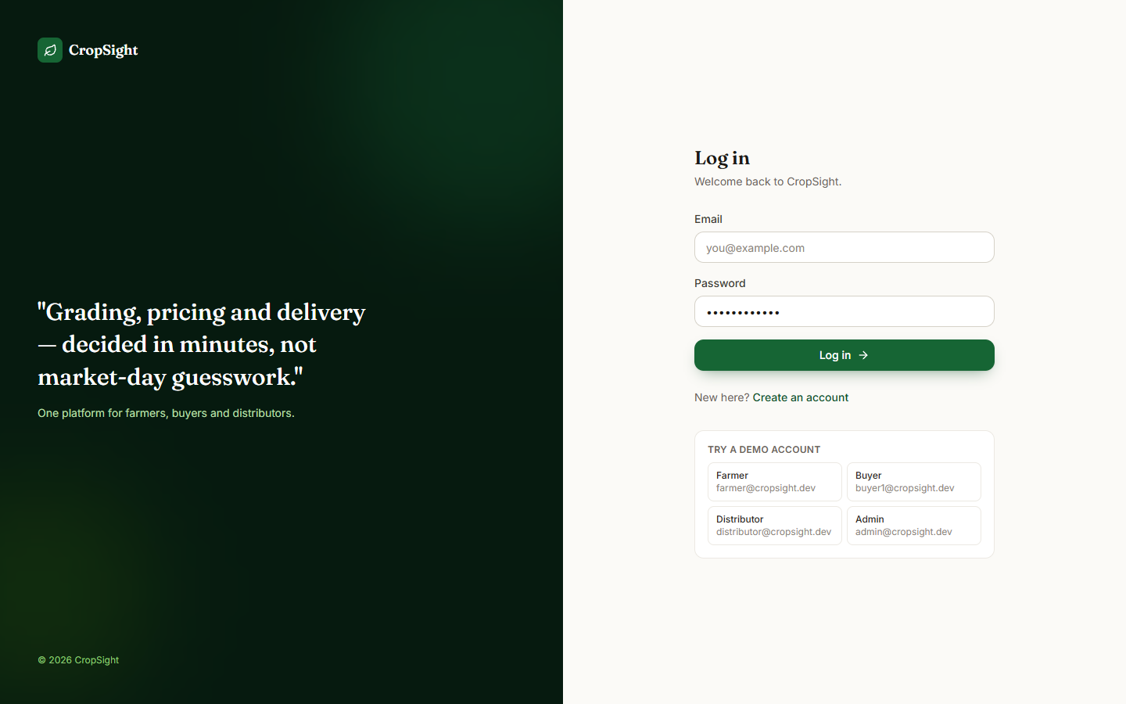  Fig. 4: Log-in page with demo-account shortcuts | 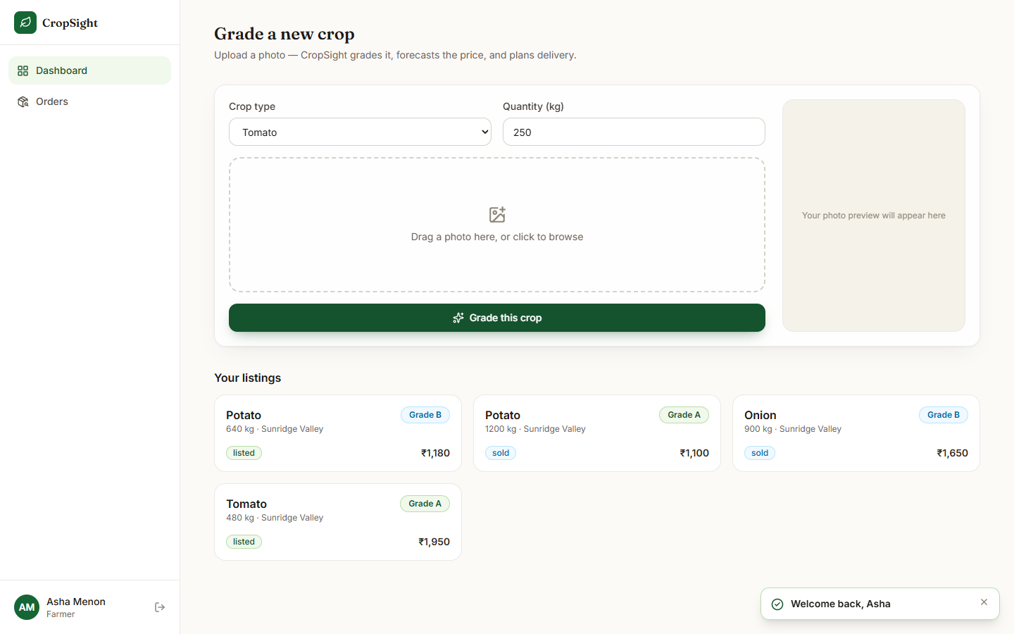  Fig. 5: Farmer dashboard: upload form and own listings

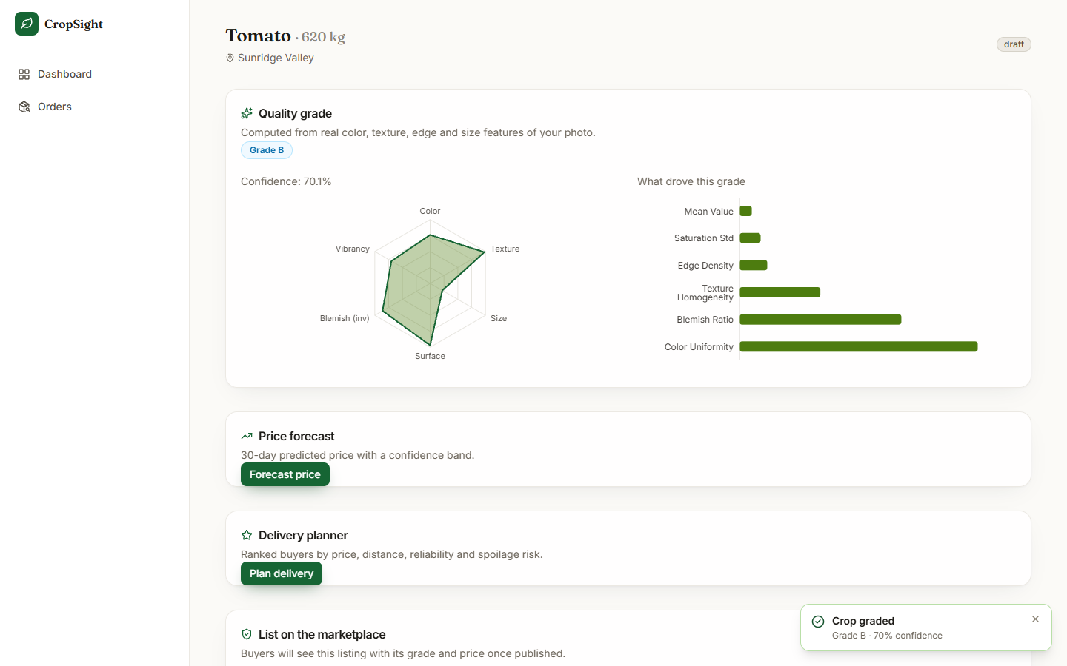  Fig. 6: Listing workspace: grade, confidence, quality radar and SHAP bars | 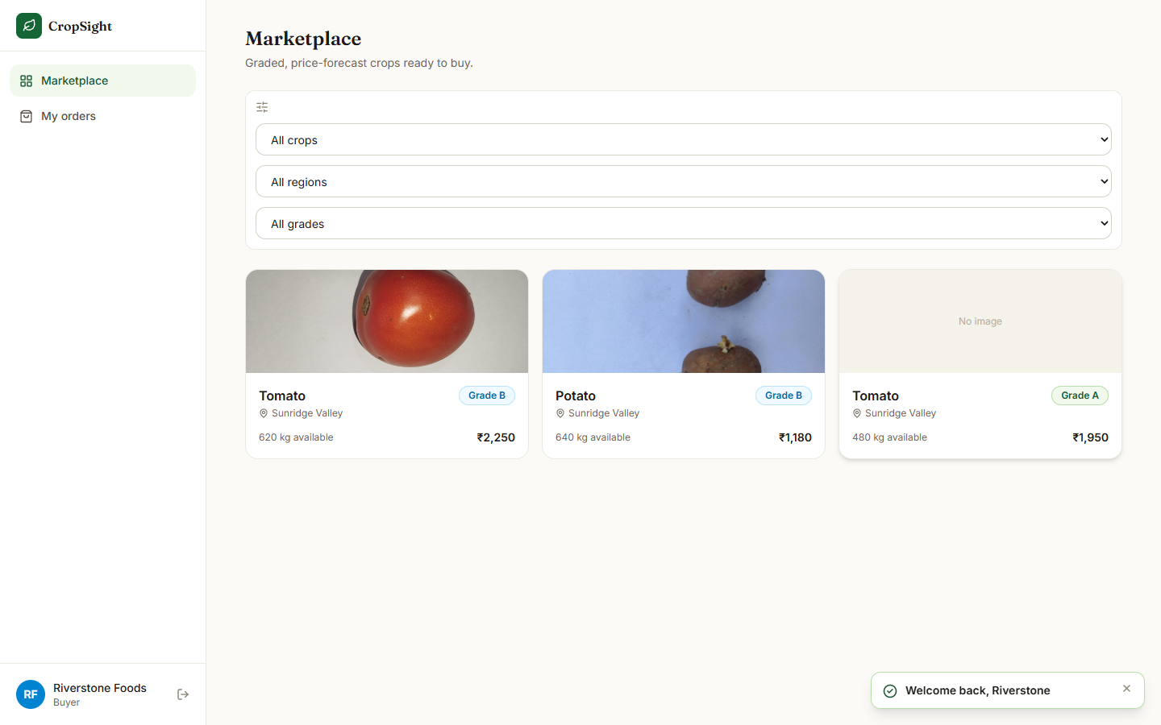  Fig. 7: Buyer marketplace with grade badges and asking prices

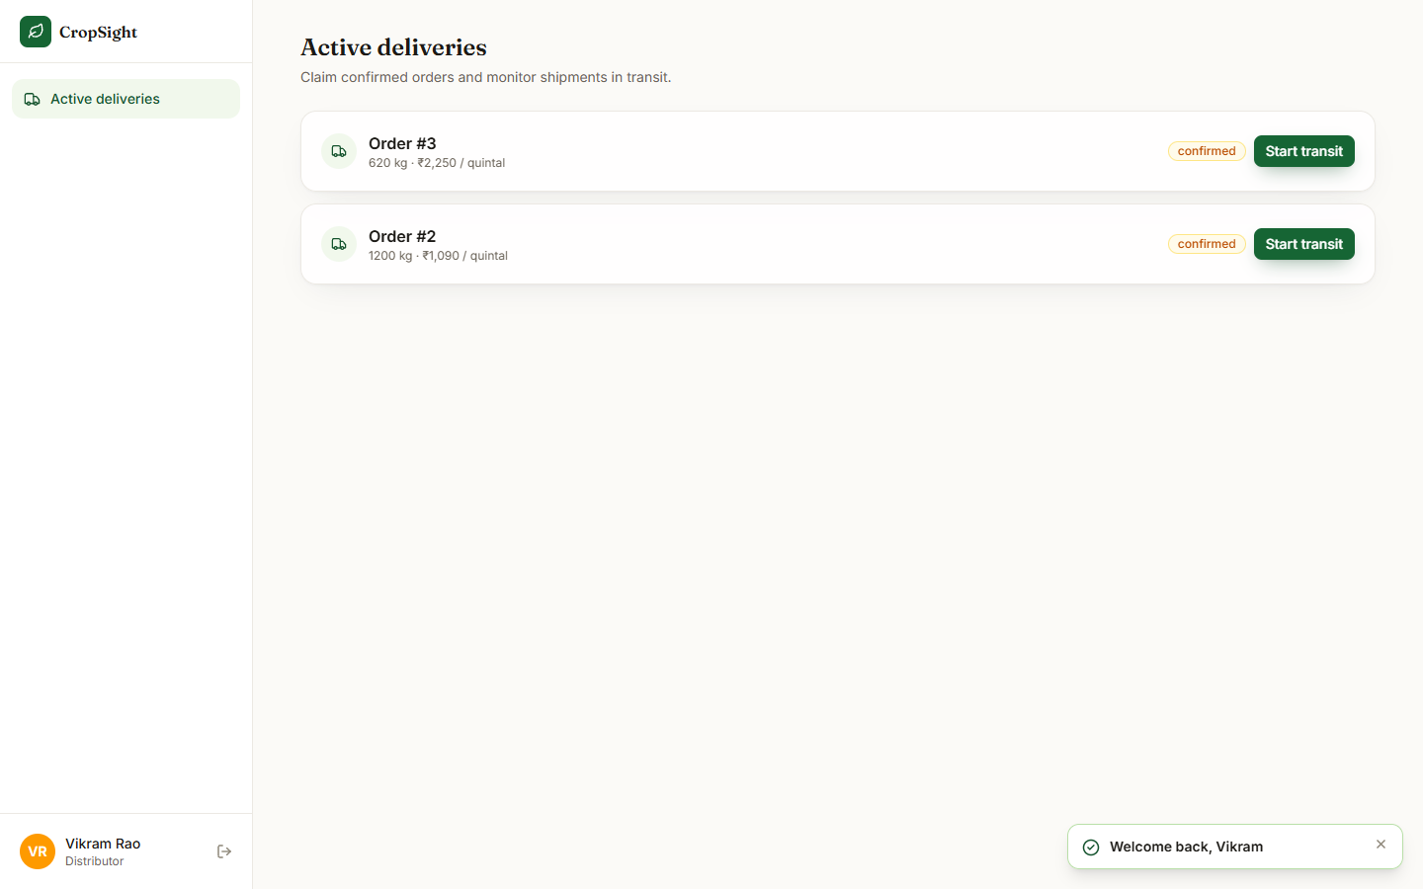  Fig. 8: Distributor: confirmed orders ready to ship | 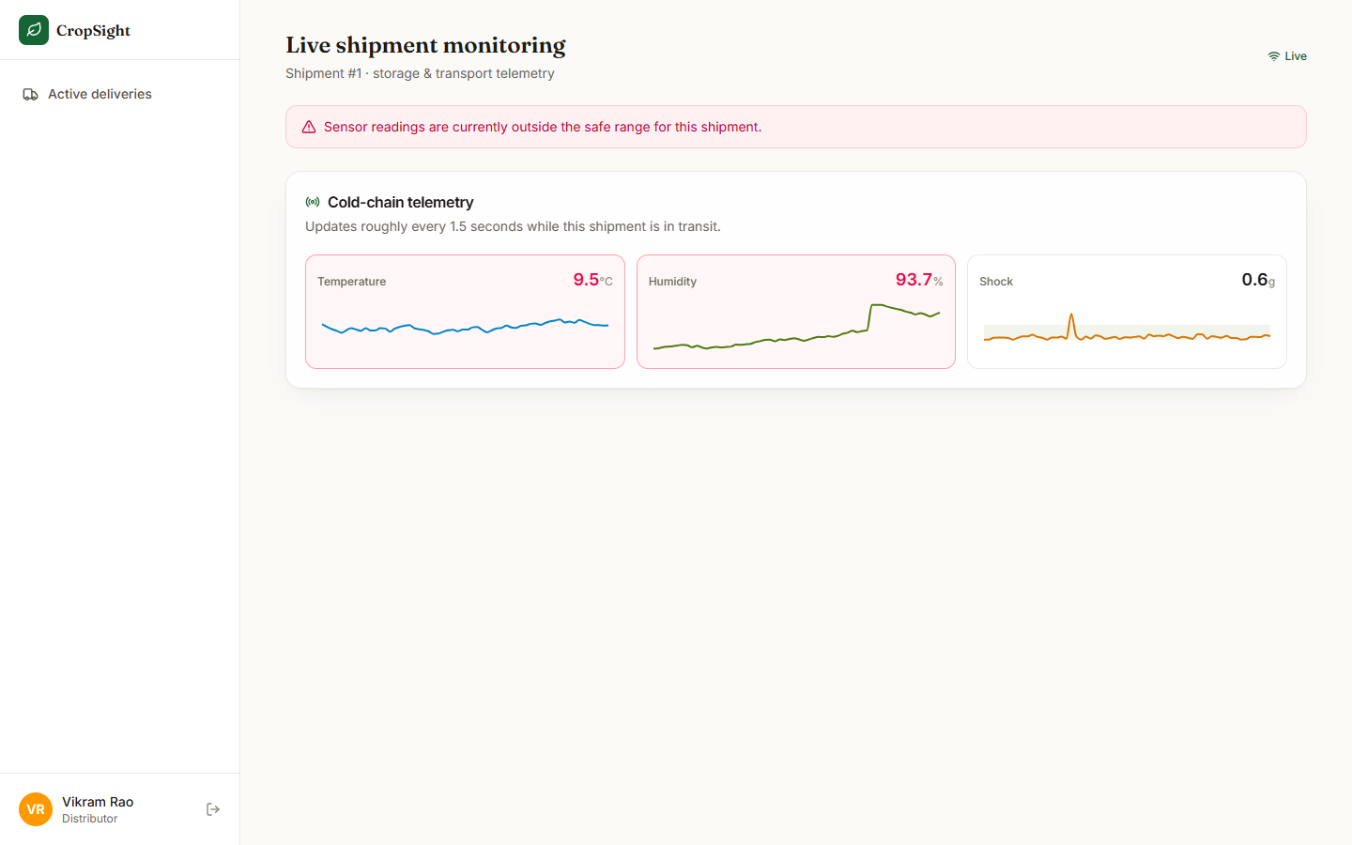  Fig. 9: Live monitoring with the out-of-range banner

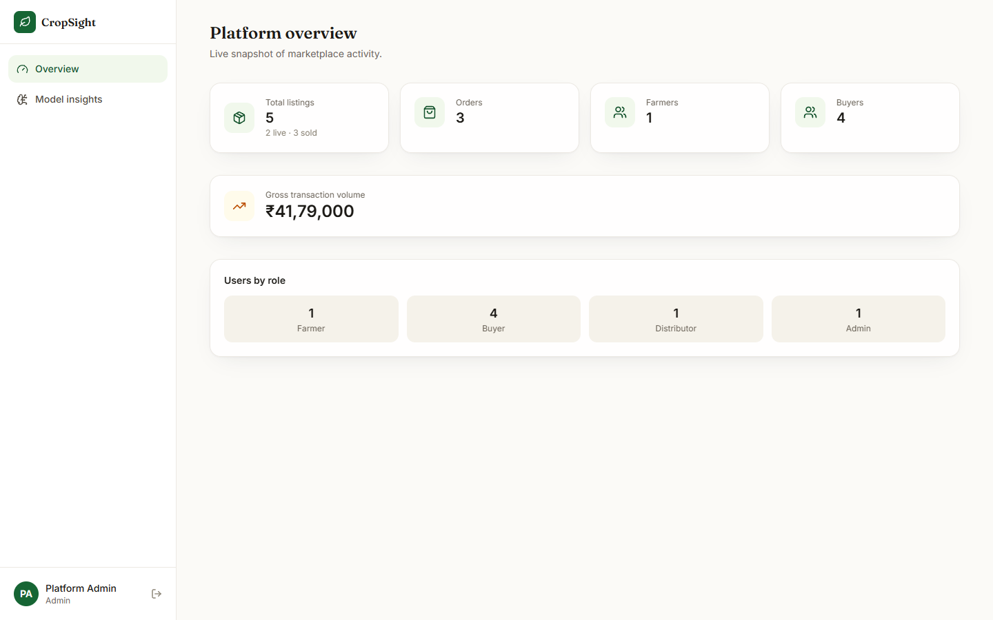  Fig. 10: Admin overview: counts and gross volume | 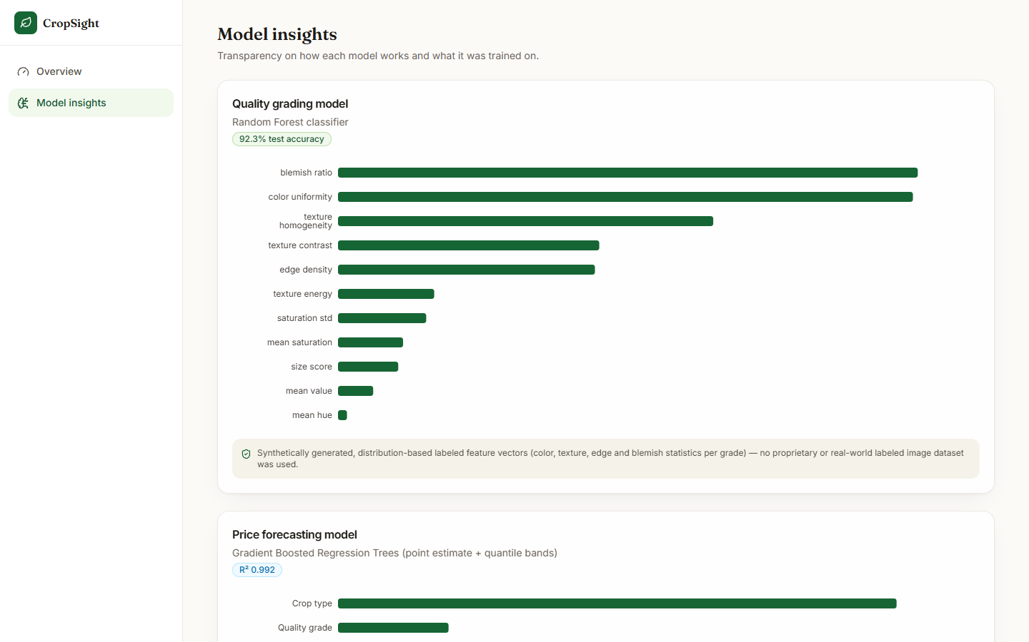  Fig. 11: Admin model insights with training-data disclosure

10 Installation and Execution
The application needs Python 3.11 and Node.js. All commands are run from the project folder 8.ProjectCode.
Table 6: Installation and execution
Step | Command | What it does
1 | cd backend; python -m venv venv; venv\Scripts\activate; pip install -r requirements.txt | Creates the environment and installs the pinned backend packages
2 | python -m app.ml.quality.train_model; python -m app.ml.price.train_model | Generates both synthetic datasets if absent and trains both models (written to app/data/)
3 | python scripts/seed_db.py | Creates the tables, eight towns, the demo accounts and one sample listing
4 | python -m uvicorn app.main:app --port 8000 | Starts the API at http://127.0.0.1:8000 (docs at /docs); do not use --reload on Windows
5 | cd frontend; npm install; npm run dev | Starts the web app at http://127.0.0.1:5190, proxying to the API
6 | python -m pytest tests -q (in backend) | Runs the 39 backend tests

Table 7: Demo accounts created by the seed script
Role | E-mail | Password
Farmer | farmer@cropsight.dev | cropsight123
Buyer | buyer1@cropsight.dev (also buyer2 to buyer4) | cropsight123
Distributor | distributor@cropsight.dev | cropsight123
Admin | admin@cropsight.dev | cropsight123

Golden path. Log in as the farmer and grade a crop photograph; forecast its price and plan delivery from the listing workspace, then publish; log in as a buyer and order the lot; confirm the order as the farmer; start transit as the distributor and open Live monitor; mark the order delivered; open the admin screens for the overview and the model cards.

